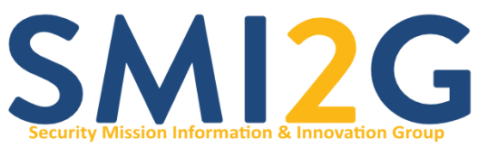
23-24 April 2026, Conseil régional d'Île-de-France (Saint-Ouen Sur Seine / Paris)

NOW OPEN: CALL FOR PITCHES AND REGISTRATION

Registration for the SMI2G 2026 is now open!
You are also kindly invited to submit pitches for project proposals. Specifically for practitioner organisations we offer the possibility to have a more generic pitch presentation covering the broader interests they have in a specific destination.
Go to our event page for registration and all further information: SMI2G 2026 event page
Every year, SMI2G hosts top-level keynote speakers, expert panel discussions as well as ground-breaking pitch sessions related to the respective calls of CL3 HORIZON Civil Security for Society. As a result, the event offers participants significant networking opportunities, supporting consortium building efforts and the sharing of valuable information concerning the Horizon Europe Security Calls.
Furthermore, we offer the opportunity to projects, networks and organisations to present their work and results on a market place. The SMI2G event is a valuable event to disseminate results and to collect feedback from a wider community. Contact the organisers if you want to learn more about the possibilities of supporting the event.
Due to rising costs, we are unfortunately required, for the first time, to introduce a small participation fee. Thanks to the generous contribution of our supporters, this fee has been kept to a minimum and amounts to only €60 in total for both days.
For further information, please contact the organisers at enquiries@smi2g.eu
The SMI2G brokerage event is organised by the EARTO Working Group Security and Defence research, the SEREN network, EOS, IMG-S, ECSO, CMINE, the Ministère de l’Enseignement Supérieur, de la Recherche et de l’espace, and Conseil régional d'Île-de-France, and is powered by ENLETS.
